Day in the Life of the Hudson River 10/15/21
PIERMONT PIER, PIERMONT
RIVER MILE: 25.4
Salt Front ~ locations from 10/14/21 ~ RM49
Lamont Doherty Earth Observatory– Margie Turrin, Laurel Zaima and 7 helpers
Pearl River High School, 43 students
Latitude 41.043189 N & Longitude – 73.89595 W
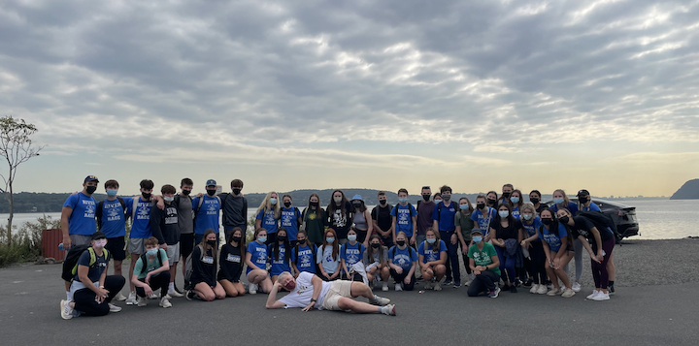

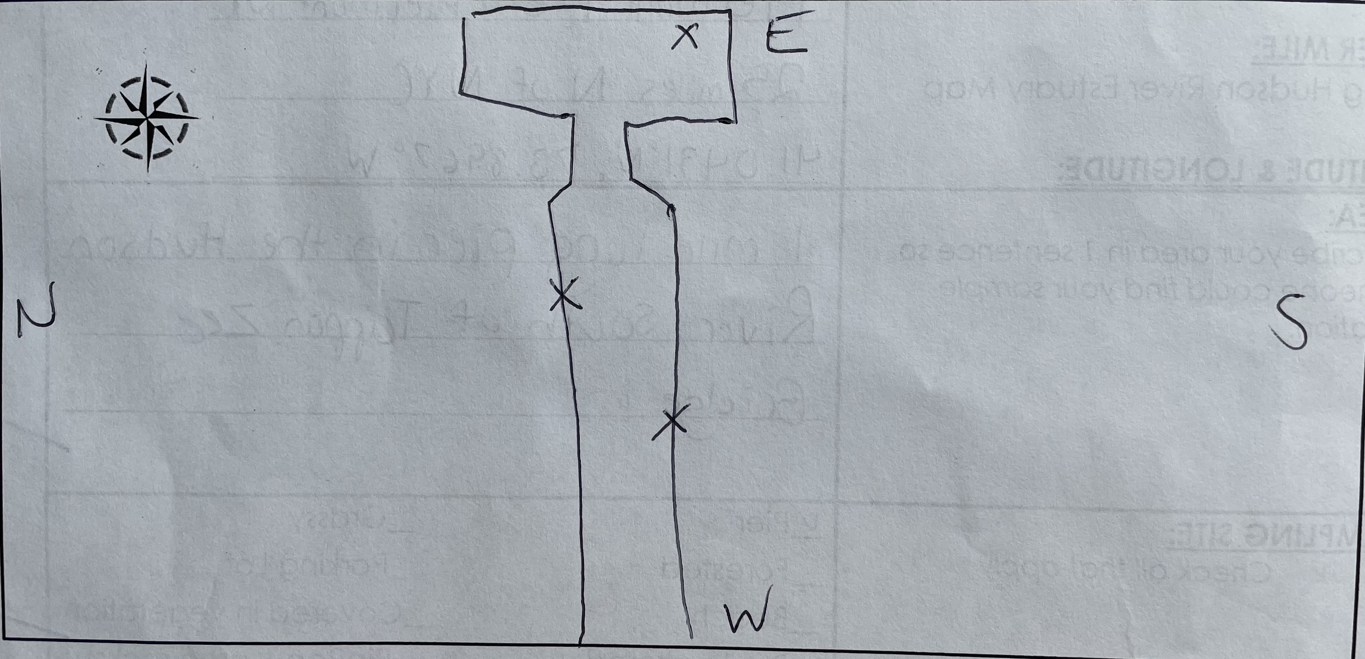
Location: Piermont Pier, Piermont, Rockland, NY
Area: Human made fishing/shipping pier at the east end, long pier with paved roadway and vegetated strip along both sides
Surrounding Land Use: 80% Urban/Residential; 20% Forested
Sampling Site: Pier, roadway in center of whole pier, parking area at the end, plants and trees along side. Shoreline riprap, collected wood in area and piping entering river on the south of sampling site
Water Depth: Varied by location on the pier and by the tide
Plants in area: 15% sumac and other plants; 85% phragmites; no submerged aquatic plants in water
River Bottom: Sandy, rocky bottom with phragmites growing in or near the water

ITEM |  |  | Time |  | Reading |  |  |  |  |  |  |  |  |  |  | Comments
Physical
Air Temperature |  |  | 9:05 AM  9:16 AM  10:07 AM  10:10 AM  10:45 AM  10:55 AM  11:00 AM  12:25 PM  12:30 PM |  | 22 º C  21 º C  24 º C  24 º C  24 º C  25 º C  22.8 º C  27 º C  27 º C |  |  |  |  |  | 71.6 º F  69.8 º F  75.2 º F  75.2 º F  75.2 º F  77 º F  73 º F  80.6 º F  80.6 º F
Wind Speed: |  |  | 9:19 AM  9:20 AM  10:08 AM  10:10 AM  10:28 AM  10:52 AM  10:54 AM  12:30 PM  12:38 PM |  | Anemometer  3.3 mph  4 mph  1.5 mph  2.2 mph  2.4 mph  2.4 mph  2.2 mph  5.7 mph  6.1 mph |  |  |  |  |  | Beaufort  1  1  1  1  1  1  1  2  2 |  |  |  |  | NE  N  NE  NE  N  N  S  SE
Weather today |  |  | No Rain, 9:16 AM – 12:30 PM Clear (<25%), 12:30-12:45PM Partly Cloudy (26-50%)
Weather past 3 days: |  |  | No rain, but warmer than usual for this time of year
Tides-  LT 12:49 PM  HT 6:50 PM |  |  | Time |  | Water Depth (cm) |  |  |  | Rising/Falling/Still |  |  |  |  | Rate of Change (cm/min)
Station 1  Station 2 |  |  | 9:08 AM  9:25 AM  10:00 AM  10:28 AM  10:46 AM  11:10 AM  12:30 PM  12:42 PM  9:16 AM  10:00 AM  10:23 AM  10:46 AM  11:05 AM  12:30 PM  12:52 PM |  | 325 cm  323 cm  303 cm  294 cm  300 cm*  290 cm  269 cm  272 cm  258 cm  256 cm  300 cm  215 cm  222 cm  220 cm  200 cm |  |  |  | -  Falling  Falling  Falling  *suspect waves  Falling  Falling  Still  -  Falling  *suspect waves  Falling  *suspect waves  Falling  Falling |  |  |  |  | -  0.12 cm/min  0.57 cm/min  0.32 cm/min  0.33 cm/min  0.42 cm/min  0.26 cm/min  0.25 cm/min  -  0.045 cm/min  1.91 cm/min  3.70 cm/min  0.37 cm/min  0.024 cm/min  0.90 cm/min
Current- |  |  | Time |  | cm/second, Knots |  |  |  |  |  | North/South |  |  |  |  | Ebb/Flood/Still
*anomalous |  |  | 9:31 AM  9:35 AM  10:15 AM  10:22 AM  11:00AM  11:10 AM  12:35 PM  12:45 PM |  | 24.1 cm/sec, 0.47 knots  18.5 cm/sec, 0.36knots  25.88 cm/s, .459 knots  106 cm/s *, 2.06 knots  28.01 cm/s, 0.55 knots  21.1 cm/s, 0.41 knots  111 cm/s*, 2.16 knots  18.55 cm/s, .361 knots |  |  |  |  |  | South  South  South  South  South  South  South  South |  |  |  |  | Ebb  Ebb  Ebb  Ebb  Ebb  Ebb  Ebb  Ebb
Water Temperature- |  |  | 8:56 AM  9:15 AM  10:00 AM  10:24 AM  10:40 AM  11:00 AM  12:40 PM |  | 21 º C  22 º C  22 º C  22 º C  22 º C  23 º C  22.1 º C, 23.7 º C |  |  |  |  | 69.8 º F  71.6 º F  71.6 º F  71.6 º F  71.6 º F  73.4 º F  71.78 º F, 74.66 º F
Turbidity- Long Sight Tube |  |  | 9:20 AM 9:47 AM 10:00 AM  10:20 AM 10:45 AM  11:06 AM  12:20 PM  12:55 PM |  | 47.25 cm  51.66 cm  52.4 cm  32.4 cm  21.6 cm  24.5 cm  23.1 cm  14.2 cm *very turbid
Chemical
Salinity- |  |  | 9:10 AM  9:15 AM  10:00 AM  10:20 AM  10:40 AM  11:00 AM  12:40 PM  12:43 PM  12:46 PM |  | Refractometer  N/R  5 ppt  N/R  5 ppt  3 ppt  5 ppt  5 ppt  N/R  5 ppt |  |  |  |  |  | Hydrometer  6 ppt  N/R  7 ppt, 5 ppt  N/R  5 ppt  N/R  6 ppt  5ppt  N/R
DO – Hach Drop count |  |  | Time |  | Temp |  |  |  |  |  | ppm DO |  |  |  |  | % saturation
*Low but the test was rechecked. |  |  | 8:56 AM  9:15 AM  9:51 AM  10:00 AM  10:24 AM  10:40 AM  11:00 AM  12:40 PM  12:57 PM |  | 21 º C  22 º C  21 º C  22 º C  22 º C  22 º C  22 º C  23.7 º C  22.1 º C |  |  |  |  |  | 10  4*  10  8  12  10, 8  8  7  8 |  |  |  |  | 110%  45%  110%  90%  130%  113%, 90%  90%  95%  90%
pH – Color Match Kit |  |  | 8:56 AM  9:15 AM  10:00 AM  10:24 AM  10:40 AM  11:00 AM  12:25 PM  12:40 PM |  | 7  7.5  7  7.5  7  7.5  7  7, 7.5
Nitrates- Hach |  |  | 8:56 AM  9:15 AM  9:23 AM  10:00 AM  10:24 AM  10:40 AM  11:02 AM  12:40 PM  12:44 PM |  | 0 ppm  0 ppm  0 ppm  0 ppm  0 ppm  0 ppm  0 ppm  0 ppm  0 ppm
Phosphates- Hach |  |  | 8:56 AM  9:20 AM  9:24 AM  10:00 AM  10:30 AM  10:40 AM  11:00 AM  12:40 PM |  | 0.2 ppm  0 ppm  0.2 ppm  0.16 ppm  0 ppm  0.18 ppm  0.45 ppm  0.26 ppm, .1 ppm
Alkalinity- Hach |  |  | 8:56 AM  9:20 AM  9:25 AM  10:00 AM  10:30 AM  10:40 AM  10:50 AM  12:30 PM  12:44 PM |  | 80 ppm  60 ppm  80 ppm  64 ppm  80 ppm  90 ppm  60 ppm  90 ppm  60 ppm
Biological
Fish |  |  | Number |  | Name |  |  |  |  |  | Length of longest |  |  |  |  | Length of smallest
 |  |  | 64  8 |  | Atlantic Silverside  Striped Bass |  |  |  |  |  | 9cm  9.8 cm |  |  |  |  | 7 cm  8 cm
Fish Totals |  |  | TOTAL: 72 |  | Diversity: 2
Macroinvertebrates |  |  | Number |  | Name |  |  |  |  |  | Length of longest |  |  |  |  | Length of smallest
 |  |  | 8  2  2  1  1 |  | Blue Crab  Grass Shrimp  Scuds  Leidy comb Jelly  Moon Jelly |  |  |  |  |  | 4.5 cm  2.5 cm  -  2.5 cm  - |  |  |  |  | 1 cm  -  -  -  -
Macroinvertebrate Totals |  |  | TOTAL: 14 |  | Diversity: 5
Sediment Core
Time | Length | H2S smell |  | Oxid Top |  | Oil |  | Grain Size |  |  |  |  | Other Features
9:36 AM  10:02 AM  12:25 PM  NA | 8 inch  2.5 inch  5 inch  10.5 cm | Yes  Yes  Yes  No |  | No  Yes  No  No |  | Yes  No  Yes  No |  | Abundant: clay, mud  Common: sand  Rare: Gravel  Abundant: clay, mud  Rare: sand, gravel  Abundant: sand, pebbles  Common: mud, gravel  Rare: clay  Abundant: clay, mud, gravel, pebbles  Rare: sand |  |  |  |  | Abundant: leaves, wood  Rare: slag  Abundant: leaves, wood  Rare: macroinverts  Abundant: mussels  Common: coal  Rare: wood, oyster shells, brick, slag  Rare: wood, oysters, mussels, macroinverts, living veg, brick, coal, slag
Boats
 |  |  | Time |  | Name |  | Color |  |  |  |  | South/North |  |  | Light/Loaded
Commercial
Residential |  |  | 12:43 PM  12:51 PM |  | Jetski  Speed Boat |  | Black, Orange  White, Blue |  |  |  |  | North  South |  |  | 4 people  Loaded- people
Observations

